Wave Tracking on the ISAC Humanoid Robot
Peter Humke
5-4-06

1 Abstract

Utilizing the Intel OpenCV libraries as a foundation for vision code, the pair of framegrabbers on the ISAC humanoid robot were used to autonomously track objects through non-static image sequences. Tracking was specifically targeted at locking onto a waved object and following that object until motion stopped. A combination of background subtraction and cam shift were utilized to detect movement and focus the framegrabbers on the motion center. Further work by Sean Begley connected a robotic manipulator to this camera tracking; moving the end-effecter to the spatial location of the tracked object.

2 Introduction

Using the ISAC humanoid robot as the test bed for this work, we attempted to create an environment to allow the visual attention of ISAC to be gathered through specific patterns of motion. When within ISAC’s field of view, waving of the hand or other object would cause the framegrabbers to lock onto the specific object and track that object until the motion of the object stopped. The eyes could then unlock from the tracking of the object, leaving the attention of the robot centered where the object stopped. Work done by Sean Begley coupled this wave tracking behavior with ISAC’s robotic manipulator, allowing it to reach out to the particular object if within the working range of the manipulator.

Attention garnering behavior can be very useful when building more complex robotic action sequences. In particular, specific visual stimuli to an action sequence does not have to be hard coded; rather it is possible to focus ISAC’s attention on objects through a more intuitive human to robot interaction. When connected with the manipulator, behavior such as object retrieval can also be done interactively by actively moving an object to within the working range of the manipulator. Therefore such a system provides an interface for robot to interact with the external world, allowing future research to focus on what to do with this interface rather than creating one from scratch.

3 Problem

Besides the actual coding of the math used to track the objects, there was one major hurdle that had to be overcome to make this project successful. Working with ISAC can be done either through direct coding of each piece of hardware connected to the robot, or through an interface already in place known as IMA 2.5. If the work was to be useable for later projects, it was preferable to use the existing IMA 2.5 structure for the code. Although more modular and easily incorporable with other defined components, the interface is far from a quick solution to hard coding the hardware pieces themselves. Work done last semester helped to simplify this problem by creating an IMA 2.5 framework for the creation of specifically visual components built using the Intel OpenCV libraries.

4 Previous Work

As mentioned before, the IMA 2.5 interface is a challenge in itself just to use. Because of this, although there were a couple of simple visual components already included within the IMA 2.5 library, these components were coded by hand and were not readily expandable into other visual components. Due to this fact, work was done last semester to incorporate the Intel OpenCV libraries into an IMA 2.5 framework that could easily be expanded to allow for easy creation of visual components. This work also included the creation of a visual component used to test the framework; a background subtraction module that could be used to detect changes within a static scene viewed through ISAC’s framegrabbers. More detail about how background subtraction works is covered in section 5.3.

5 Object Tracking

5.1 Overview of Intel OpenCV

Intel has created an open source computer vision library to help aid programmers in creating vision code for any application. This powerful library first defines a set of classes useful within the vision algorithms; from a basic image class used to hold the images being manipulated, to a histogram class used to hold calculated color histogram information about sub-image regions.

These classes are used to build a large set of functional tools comprising most of the well-defined visual operations, ranging from basic color thresholding and contour processing, all the way up to gesture recognition and Eigen objects. More sophisticated visual processing modules can easily be created using these methods as a foundation.

5.2 Overview of Object Tracking

The object tracking routine created for ISAC was built from this IMA 2.5 OpenCV framework and was incorporated into the IMA 2.5 library for future use. No single visual routine was used to do the object tracking, rather an array of algorithms were used to create the final tracking module. This was both to display the expandability of the IMA 2.5 OpenCV framework and also because it allowed the tracking to be done autonomously without needing have a priori information about the object to be tracked.

The basic structure for the object tracking module can be seen in figure 1. A brief description of each step is defined below, with mathematical models for each of the operations following the outline.

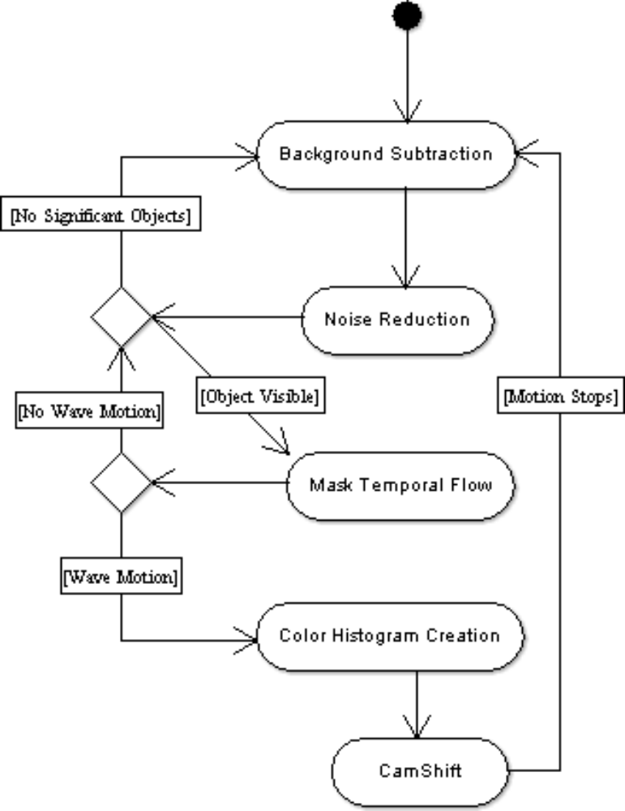
Figure 1: Wave Track Activity Diagram

1. Since the cameras are initially non-moving, background subtraction was first used to filter out moving and non-moving objects within the scene. Either static or running average background subtraction could be used, however the running average has the advantage of slowly removing ambient changes in the room as time passes.

2. Using this background subtraction image, an opening morphological operator was used to reduce noise in the image and remove objects that were too small to be significant. This difference image was used as a mask for objects contained within the color image.

3. If objects were still visible within the mask, tracking of the largest connected component was initiated. (Note that the largest object within the mask was used to track because we only want to track a single object.) Although officially tracking of the object has begun, actual camera motion is not going to occur until the tracked object moves on a predefined path, indicating that this is an object to fix attention upon (in this case waving).

4. Temporal optical flow was calculated by incorporating the mask image into a motion history image. Optical flow that exhibits side-to-side lateral motion indicates that waving has occurred and the cameras should pay attention to the object.

5. If this motion pattern does not appear and the object disappears from the field of vision, tracking ends and the program moves back to the background subtraction phase.

6. If wave motion is detected, then a color histogram of the masked moving region within the color image, along with a rough size estimate for the object, is calculated and used as the object definition.

7. Because background subtraction can only work in situations where the background stays static, it can no longer be used as a viable method of tracking while the cameras move. Instead, cam shift based upon the previously created object definition tracks the object through the frames. The cam shift uses a relatively small search window to ensure motion stability, while also decreasing computation time.

8. Once motion between frames falls below some constant epsilon, tracking ends and background subtraction begins again.

5.3 Background Subtraction

Background subtraction at its most basic level is simple image differencing. An initial background scene is created. To remove tiny bits of noise within the image, average and standard deviation images can be calculated for every pixel over N previous images can be calculated.

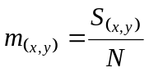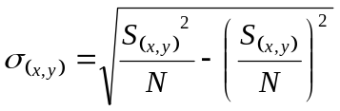

S is the sum of the set of N static images, m is the average image and σ is the standard deviation image.

By subtracting each consecutive image from this background image, we can identify those locations within the scene that have changed as those pixels with a significant difference from their original value.

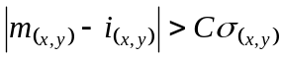

Where i is the current image and C is a constant multiplier.

To decrease the affect of lighting changes or other ambient factors within the scene, it may be preferable to continuously update the background image to better reflect the current conditions. This is accomplished through a weighted sum between the original background image and the current image.

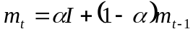

Where α is a weighting factor, m_{t} is the background for the next image, m_{t-1} is the current background and I is the current image.

5.4 Erosion and Dilation

Morphological operators will not be covered in depth within this paper; however a quick overview of their affect on images is presented below. For more information regarding morphological operators please see the references section. Only binary images were used with these morphological operators.

During dilation, a structuring element is applied to the image causing growth of those regions which have the binary value of one.

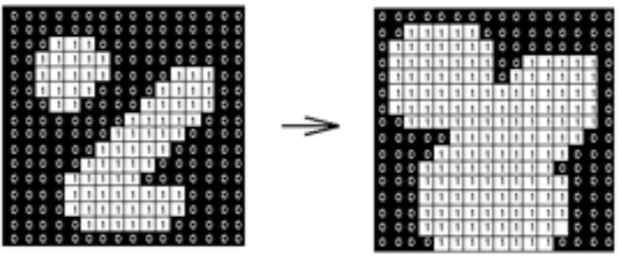
Figure 2: Example of dilation within an image

Erosion is almost identical except that the structuring element will cause a growth in those areas with a binary value of zero.

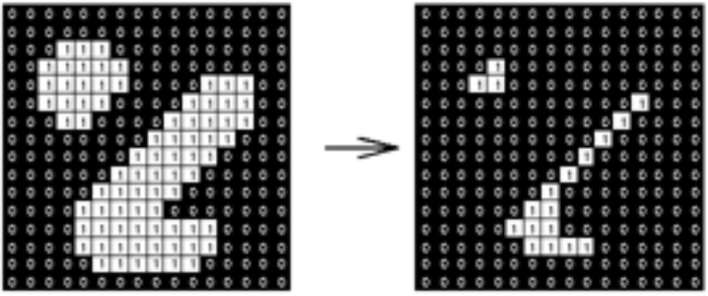
Figure 3: Example of erosion within an image

To remove noise, the opening operator was used to remove small objects, then attempt to recreate those missing portions of the large objects. Opening is defined as:

Dilation( Erosion( ) )

5.5 Optical Flow Vector

Optical flow within an image can be calculated through the creation of a motion history image. Overlaying previously captured masks (or silhouette images) into a single image such that older images are consecutively darker shades of gray creates this motion history image. In this case, only motion between the last two frames is required. Motion direction and magnitude is calculated from the x and y partial derivative images of the motion history image.

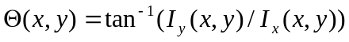
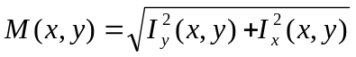

Where I_{x} and I_{y} are the partial derivatives with respect to x and y of the image I, θ(x,y) is the orientation of the flow vector at a pixel location (x,y) and M(x,y) is the magnitude of the gradient at the pixel location (x,y).

5.6 Cam Shift

Cam shift stands for continuously adaptive mean shift and is a variation on the mean shift algorithm, containing the ability to calculate the size and orientation of the viewed region. The first thing that the Cam shift algorithm must have is a color probability distribution for the colors contained within an object. Using this color distribution as a look up table for the image, a probability distribution map is created.

Mean shift is applied to this probability distribution map. The algorithm finds the center of mass for a subset region of the distribution map. Mean shift then sets this center as the new subset region center, and the algorithm iterates through this process until the center of mass converges.
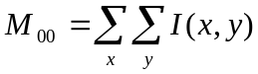
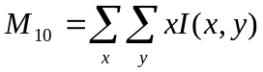
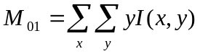
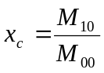
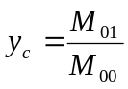

Where M₀₀, M₁₀ and M₀₁ are the zero and first moments in the x and y directions for an image I. x_{c} and y_{c} are the centroids of mass within the given sub-region of the image being summed over.

Once mean shift has converged and calculated the location within the image with the highest probability of being the tracked object, cam shift can calculate the size and orientation of the object using the second moments of the probability distribution.

We can define the second moments of the image as:

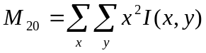
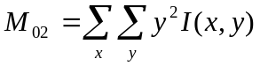

Using these moments along with the zero and first moments defined above, set up the following variables:

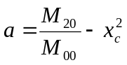
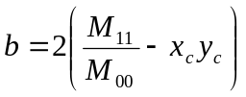
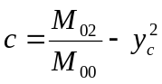

From here we can now define the orientation, width, and length of the cam shift region as:

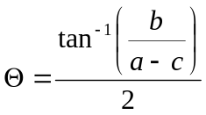
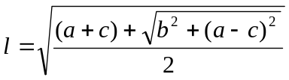
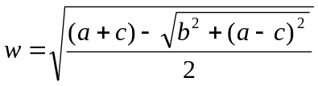

When used together, cam shift is a very powerful tracking algorithm that works well in situations where the probability distribution of the tracked object is fairly unique within the scene. This algorithm is fairly robust and only breaks down in the most color invariant of scenes.

6 Arm Motion

6.1 Three-Space Coordinate Determination

ISAC is equipped with two framegrabbers having a known distance of separation between them. This makes is possible to use stereopsis between the framegrabbers to calculate the depth to a common object. Transforming this depth into the coordinate system will determine the z location for that object in space.

6.2 Combination with Wave Tracking

Using the wave tracking method to focus the attention of ISAC on a particular object it is possible to create a form of hand-eye coordination. Two-space coordinate information can be obtained from the relative transformations between the camera orientations and the robot base. This can be connected with z-depth estimation information for an object in the center of their field of view. The robotic manipulator is sent this location and through the inverse kinematic equations can calculate the arm angles required to move the end-effecter to that position.

For more detailed information about how to calculate z-depth from stereopsis or how ISAC’s manipulator was connected to the wave tracking system, please refer to the paper written by Sean Begley. His work involved connecting these components together.

7 Final Product

7.1 Results and Discussion

Although the mathematics and logical flow behind the object tracking method was solid, there was not enough time to spend testing and debugging the system. A number of problems presented themselves that caused long delays along the way. Mentioned before, the IMA 2.5 interfacing standard caused headaches all along the way; from slow response times within the component manager to miscellaneous problems with the inclusion OpenCV library. Because the tools used to run the IMA 2.5 interfaces are academic enterprises and not final products, constant revision to these programs would occasionally cause instability with the visual components.

Using the OpenCV framework put into place last semester along with the vision code base that has been written this semester, it should not take a lot of time for someone to resume debugging of the wave tracking system. This semester did show that the OpenCV framework that had been established does work smoothly, and future integration of new vision modules will not be a tedious process with a steep learning curve.

7.2 Conclusion

The goal of the project was to implement an IMA 2.5 module that could track an object initially being waved until the object comes to rest. By incorporating work done by Sean Begley, an interface could be created by which objects of interest do not have to be hard coded into ISAC, rather attention to inputs could be activated through this more intuitive human fashion. This work will also serve as an extended foundation for the IMA 2.5 OpenCV framework that was set up last semester for the easy creation and inclusion of vision components into the ISAC module library.

Progress was good, but was hindered during final testing phases due to many factors outside of our control. Despite having hang-ups in getting a running demonstration, working with ISAC and the OpenCV libraries in depth has been an excellent learning experience. Interacting with a robot as sophisticated as ISAC gave a lot of prospective on the complexity of the interplay between the brain and the components of a multi-functional robot.

8 Problems and Future Recommendations

8.1 Problems

After working on the project, there are still a few problems left to tackle before the wave-tracking system is perfect. One issue that was not resolved effectively is during the creation and tracking of a probability image. Currently after wave motion is detected, a person standing within the scene would still be detected and their colors would not be masked off when calculating the histogram. A possible solution to this could be to use the motion history image to compute the region that is actually in motion, then mask off the remaining non-moving detected objects.

Further enhancement of the wave tracker would be to incorporate a simple camera nod to indicate that ISAC’s attention has been caught or released. This could be done by adding in a routine that simply moves the cameras down and up before starting the tracking or after the motion has stopped.

If the tracking seemed to be lagging too far behind the object, the kalman filter could be implemented to estimate the best guess location for where the object would be within the next frame. Care should be taken with this because frames will be coming through the IMA 2.5 interface, which may not be time deterministic.

8.2 Future Recommendations

Enhancements to this project or the IMA 2.5 visual library would be welcome additions to ISAC. Possible topics include facial recognition, hand-shaking capability or more advanced tracking routines (such as level set contours).

Each of these topics would pose a challenging problem for ISAC, but further work in this area will also prove rewarding to all those who use ISAC.

9 Bibliography

Begley, Humke, Kientz. ISAC IMA OpenCV Integration - Visual Component Creation. May 2nd 2006. <\\cis\crl\ima\Fall2005 IndepStudy\Paper\OpenCV ISAC Paper Final - 5-2-2006.doc>.

Begley. Implementation of a Wavetracking Algorithm on ISAC. May 2nd 2006. <\\cis\crl\ima\Fall2005 IndepStudy\Spring Paper\Sean_Spring_2006_Paper.doc>.

Comaniciu, Meer. “Mean Shift: A Robust Approach Toward Feature Space Analysis”. IEEE Transactions On Pattern Analysis and Machine Intelligence. May 2002. <http://ieeexplore.ieee.org/iel5/34/21601/01000236.pdf?tp=&arnumber=1000236&isnumber=21601>.

Fisher, Perkins, Walker, Wolfart. Image Processing Learning Resources. 2004. <http://homepages.inf.ed.ac.uk/rbf/HIPR2/erode.htm>.

Intel Corporation. Open Source Computer Vision Library Reference Manual. December 2000. <http://www.prip.tuwien.ac.at/Teaching/WS/ProgBVS/docs/OpenCVMan.pdf>.

Intel Corporation. Intel® Open Source Computer Vision Library. <\\cis\crl\ima\Fall2005 IndepStudy\OpenCV\docs\ref\opencvref_cv.htm>.

Vanderbilt Intelligent Robotics Lab Intranet. Eds. Anthony Alford & Mark Cambron. May 3rd 2006. <\\cis\common\InetPub\wwwroot\IRL\default.htm>

